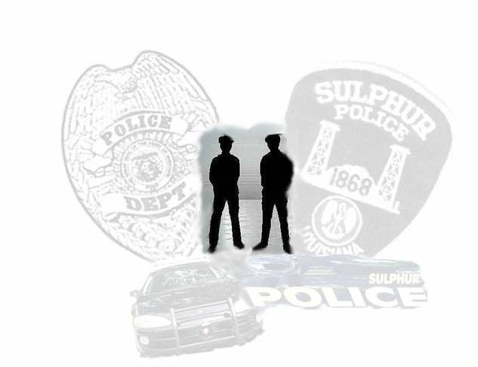
Sulphur Police Department PROTECT AND SERVE


January 28, 2014
News Release of Arrests
SULPHUR - Sulphur Police Department reported on January 24-27, 2014 that officers of the department investigated four traffic accidents reporting no injuries and responded to several other incidents resulting in nine arrests.
Richard Andrew Albert, White Male, Age 27 of Rainbow Road, Orange, Texas was arrested and booked into the Sulphur City Jail for driving left of center line, no driver’s license and driving while under the influence.
Erika Faron McDaniel, White Female, Age 27 of North Huntington Street, Sulphur was arrested and booked into the Sulphur City Jail for an outstanding bench warrant and contempt of court.
Rebecca Emily Wilke, White Female, Age 29 of Vinton, Louisiana was arrested and booked into the Sulphur City Jail for theft of goods.
Jessica Ann Bertrand, White Female, Age 35 of Thelma Lane, Lake Charles was arrested and booked into the Sulphur City Jail for theft of goods.
Cody Ryan Gann, White Male, Age 27 of Maplewood Drive, Sulphur was arrested and booked into the Sulphur City Jail for domestic abuse battery and disturbing the peace by language.
Meghan Rennee Hetkes, White Female, Age 21 of Ann Street, Sulphur was arrested and booked into the Sulphur City Jail for theft of goods.
Trenton Michael Guy, White Male, Age 21 of Ann Street, Sulphur was arrested and booked into the Sulphur City Jail for theft of goods.
Warren Lavell Washington, Black Male, Age 28 of Douglas Road, Dequincy was arrested and booked into the Sulphur City Jail for disturbing the peace by public intoxication.
Jordan Alonzo Haines, Black Male, Age 19 of Palm Drive, Sulphur was arrested and booked into the Sulphur City Jail for unauthorized moveable of a vehicle.

If you have any information concerning these crimes or any other criminal acts, please call 337-527-4550,

